**Sampling Techniques in Statistics**

Sampling is like taking a small bite of a big pie to get a taste of the whole thing. It allows us to study a portion of a population and still make accurate conclusions about the entire group. But with so many ways to sample, how do you know which method to choose? Let’s break it down in simple terms.

**Why is Sampling Important?**

* Imagine trying to survey every single person in your city to understand their shopping habits. It would take forever and cost a ton of money! Instead, you can survey a smaller group that represents the whole city. This way, you get valuable insights without needing to talk to everyone.
* Sampling is all about making sure that small group you choose is a good reflection of the bigger picture. If you do it right, you can trust that your findings are accurate. If you do it wrong, your results might be misleading.
* Data sampling is the process of selecting a portion of a dataset to analyze, rather than using the entire dataset. This is often necessary because working with huge datasets can be computationally expensive and time-consuming. Effective sampling allows you to:
* **Reduce computation time** while still capturing the essence of your data.
* **Avoid overfitting** by training models on diverse, representative samples.
* **Identify trends and patterns** that generalize to the whole dataset.

**Types of Sampling**

There are two big categories of sampling:

1. **Probability Sampling**
2. **Non-Probability Sampling**.

Each has its strengths and weaknesses, depending on what you’re trying to do

**1. Probability Sampling**

In probability sampling, everyone in the population has a known chance of being selected. It’s like drawing names out of a hat, where everyone has a fair shot at being picked.

**A. Simple Random Sampling:**

This is the most straightforward method. You just randomly pick people or items from your population. It’s fair and easy, but you need to have a list of everyone in the population, which isn’t always possible.

* **Example**: Election Polling  
  A survey company wants to predict election results by selecting 1,000 voters randomly from a database of 1 million registered voters. Since each voter has an equal chance of being selected, this ensures unbiased results.
* **Use When**: The population is homogeneous, and random selection is feasible.

**B. Stratified Sampling**

Here, you divide your population into different groups (like age or income brackets) and then randomly sample from each group. This ensures that all the important groups are represented in your sample.

* **Example:** Quality Control in Manufacturing  
  A factory produces 10,000 mobile phones daily. Instead of checking all phones, the quality control team inspects every 100th phone coming off the assembly line to ensure consistent quality.
* **Use When**: The population is sequentially organized, and you need evenly spread samples.

**C. Systematic Sampling**

Instead of picking randomly, you select every nth person from a list. For example, if you want to sample 10% of a population, you could pick every 10th person on the list. It’s a simple way to sample, as long as your list is in a random order.

* **Example: Educational Research**  
  A researcher wants to analyze student performance in a school. Since there are different grades (e.g., elementary, middle, and high school), the researcher divides students into these strata and takes proportionate samples from each group.
* **Use When**: The population has distinct subgroups (strata), and you need fair representation.

**D. Cluster Sampling**

This method is useful when your population is spread out over a large area. You divide the population into clusters (like neighborhoods) and randomly pick a few clusters to study. Then you study everyone in those clusters.

* **Example** : Healthcare Survey  
  A health organization wants to study diabetes prevalence in a country. Instead of surveying individuals randomly across the country, they randomly select 5 cities (clusters) and survey all individuals within those cities.
* **Use When**: The population is naturally divided into clusters, and surveying entire clusters is more practical than random selection.

**E. Multi-Stage Sampling**

This is like cluster sampling, but with an extra step. After picking your clusters, you randomly sample within those clusters. It’s useful for large-scale studies

**Example: National Health Survey**  
A government health department wants to conduct a nationwide health survey to analyze obesity rates. Since surveying every individual in the country is impractical, a multi-stage sampling approach is used:

Stage 1 (Cluster Sampling): Randomly select 5 states from the country.  
Stage 2 (Sub-cluster Selection): Within each state, randomly choose 3 districts.  
Stage 3 (Further Selection): In each district, randomly select 4 neighborhoods.  
Stage 4 (Final Sampling): From each neighborhood, randomly select 50 individuals for the survey.

This method reduces travel costs and effort while ensuring a representative sample.

**2. Non-Probability Sampling**

Non-probability sampling doesn’t give everyone in the population a chance to be selected. This can make it less reliable, but it’s often quicker and easier.

This type of sample is easier and cheaper to access, but it has a higher risk of sampling bias. That means the inferences you can make about the population are weaker than with probability samples, and your conclusions may be more limited. If you use a non-probability sample, you should still aim to make it as representative of the population as possible.

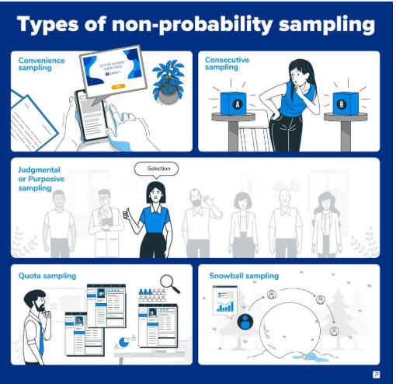

**A. Convenience Sampling**

This method is all about picking what’s easiest. You sample the people or items that are easiest to reach. It’s not the most accurate, but it’s fast and cheap.

* **Example**: Early Product Feedback  
  A startup wants feedback on its new food delivery app. Instead of surveying a random population, they test the app with employees, friends, and family members first.
* **Use When**: You need quick and easy data collection, but statistical validity is not critical.

**B. Judgmental or Purposive Sampling**

Here, you pick people or items that you think are the most representative of your population. It’s based on your judgment, so it can be biased, but it’s useful when you need specific insights.

* **Example: Expert Interviews for Market Trends**  
  A company wants insights on AI industry trends, so instead of surveying the general public, they only interview AIresearchers and tech CEOs, believing they have the best insights.
* **Use when?**

When expert knowledge is required

Useful in niche studies

* **Drawback:**

Selection bias (only a small, handpicked group is surveyed.

**C. Quota Sampling**

You decide in advance how many people you want from each group (like gender or age) and then find people until you fill those quotas. It’s similar to stratified sampling but less random.

* **Example: Customer Satisfaction by Age Group**  
  A company wants 50% young customers (under 30) and 50% older customers (above 30) to give feedback on a new product. Instead of randomly sampling, they intentionally stop sampling after reaching each quota.
* **Why Use?**

Ensures representation from specific groups

Useful when **proportions matter** (e.g., age, gender, income levels)

* **Drawback:**

Can introduce selection bias if participants aren’t chosen randomly

**D. Snowball Sampling**

This method is used when it’s hard to find participants. You start with a few people and ask them to refer others. It’s like a chain reaction, but it can be biased because you’re only reaching people who know each other.

* **Example**: Studying Drug Addiction Patterns  
  Researchers studying illegal drug use may struggle to find participants. They start by interviewing a few known users and then ask them to refer others, creating a "snowball effect."
* **Use When**: The target population is hard to reach or hidden.

**E. Volunteer Sampling**

In volunteer sampling, people choose to participate on their own. This method is often used in online surveys or experiments. It can be biased because only certain types of people might volunteer.

* **Example:** Online Survey for Fitness Enthusiasts  
  A fitness company posts a survey link on social media, asking gym-goers to provide feedback on workout supplements. Only people who are interested and willing will take the survey.
* **Why Use?**

Easy to get participants quickly

Low-cost, widely used in **online surveys**

* **Drawback:**

Biased because only people who care about the topic will respond